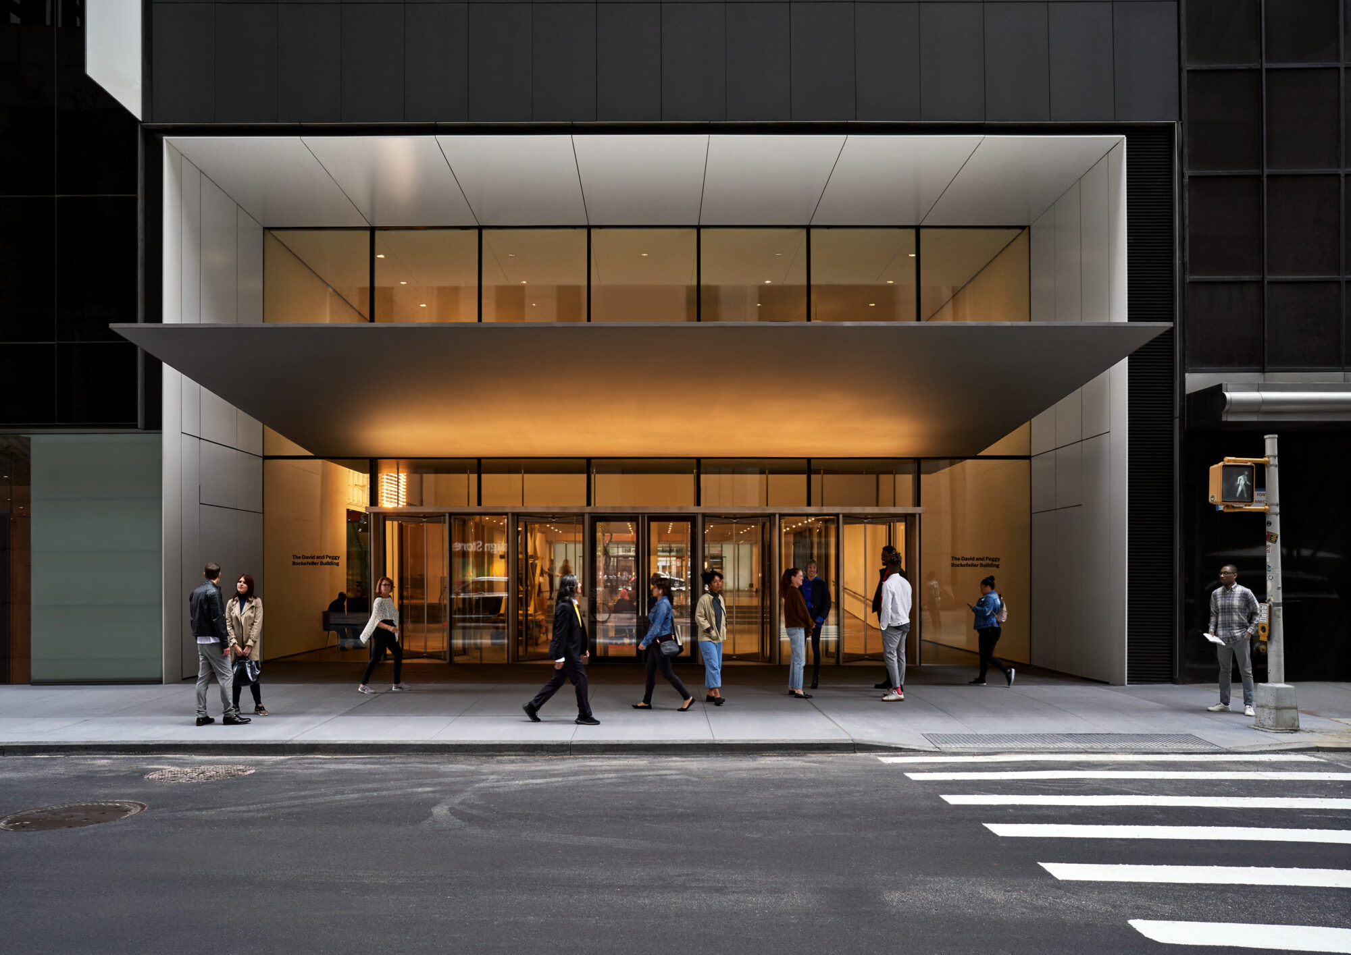

The Museum’s main entrance on West 53rd Street. © 2023 The Museum of Modern Art, New York.

Photo: Noah Kalina

The Museum of Modern Art Uses Sennheiser MobileConnect to Deliver an Inclusive Listening Experience

The New York City museum’s visitors hear audio at their own pace and volume.

New York, New York July 10, 2023 – The Museum of Modern Art (MoMA) in New York City has become one of the first organizations to work with Sennheiser to customize the iOS and Android app for MobileConnect, an easy-to-use and intuitive Assistive Listening system that utilizes the Bring-Your-Own-Device philosophy.

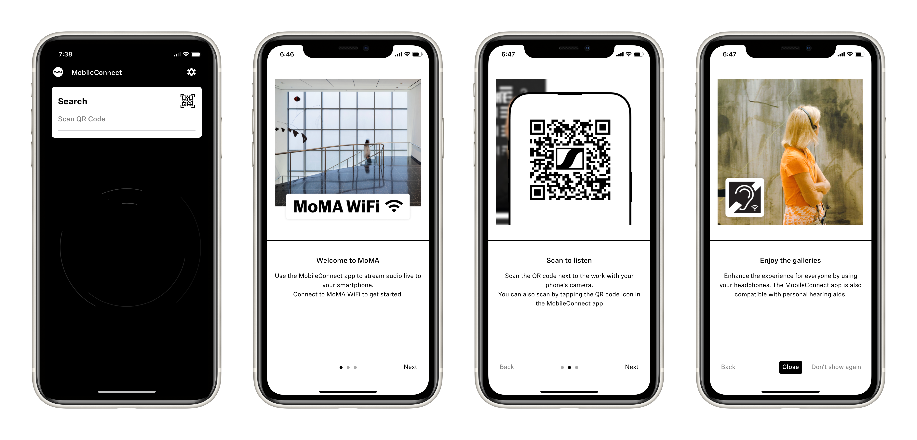

MobileConnect is available to visitors in the Museum, with streaming audio that can perfectly sync with video and film works of art. MoMA visitors can use MobileConnect as an accessible assistive listening solution via their personal smartphones, without the need for cumbersome, and potentially difficult to clean, wired headphones.

Another way MoMA is using MobileConnect is to allow visitors to experience multiple audio works in the same space, without creating an unpleasant cacophony or compromising audio quality or visitor experience.

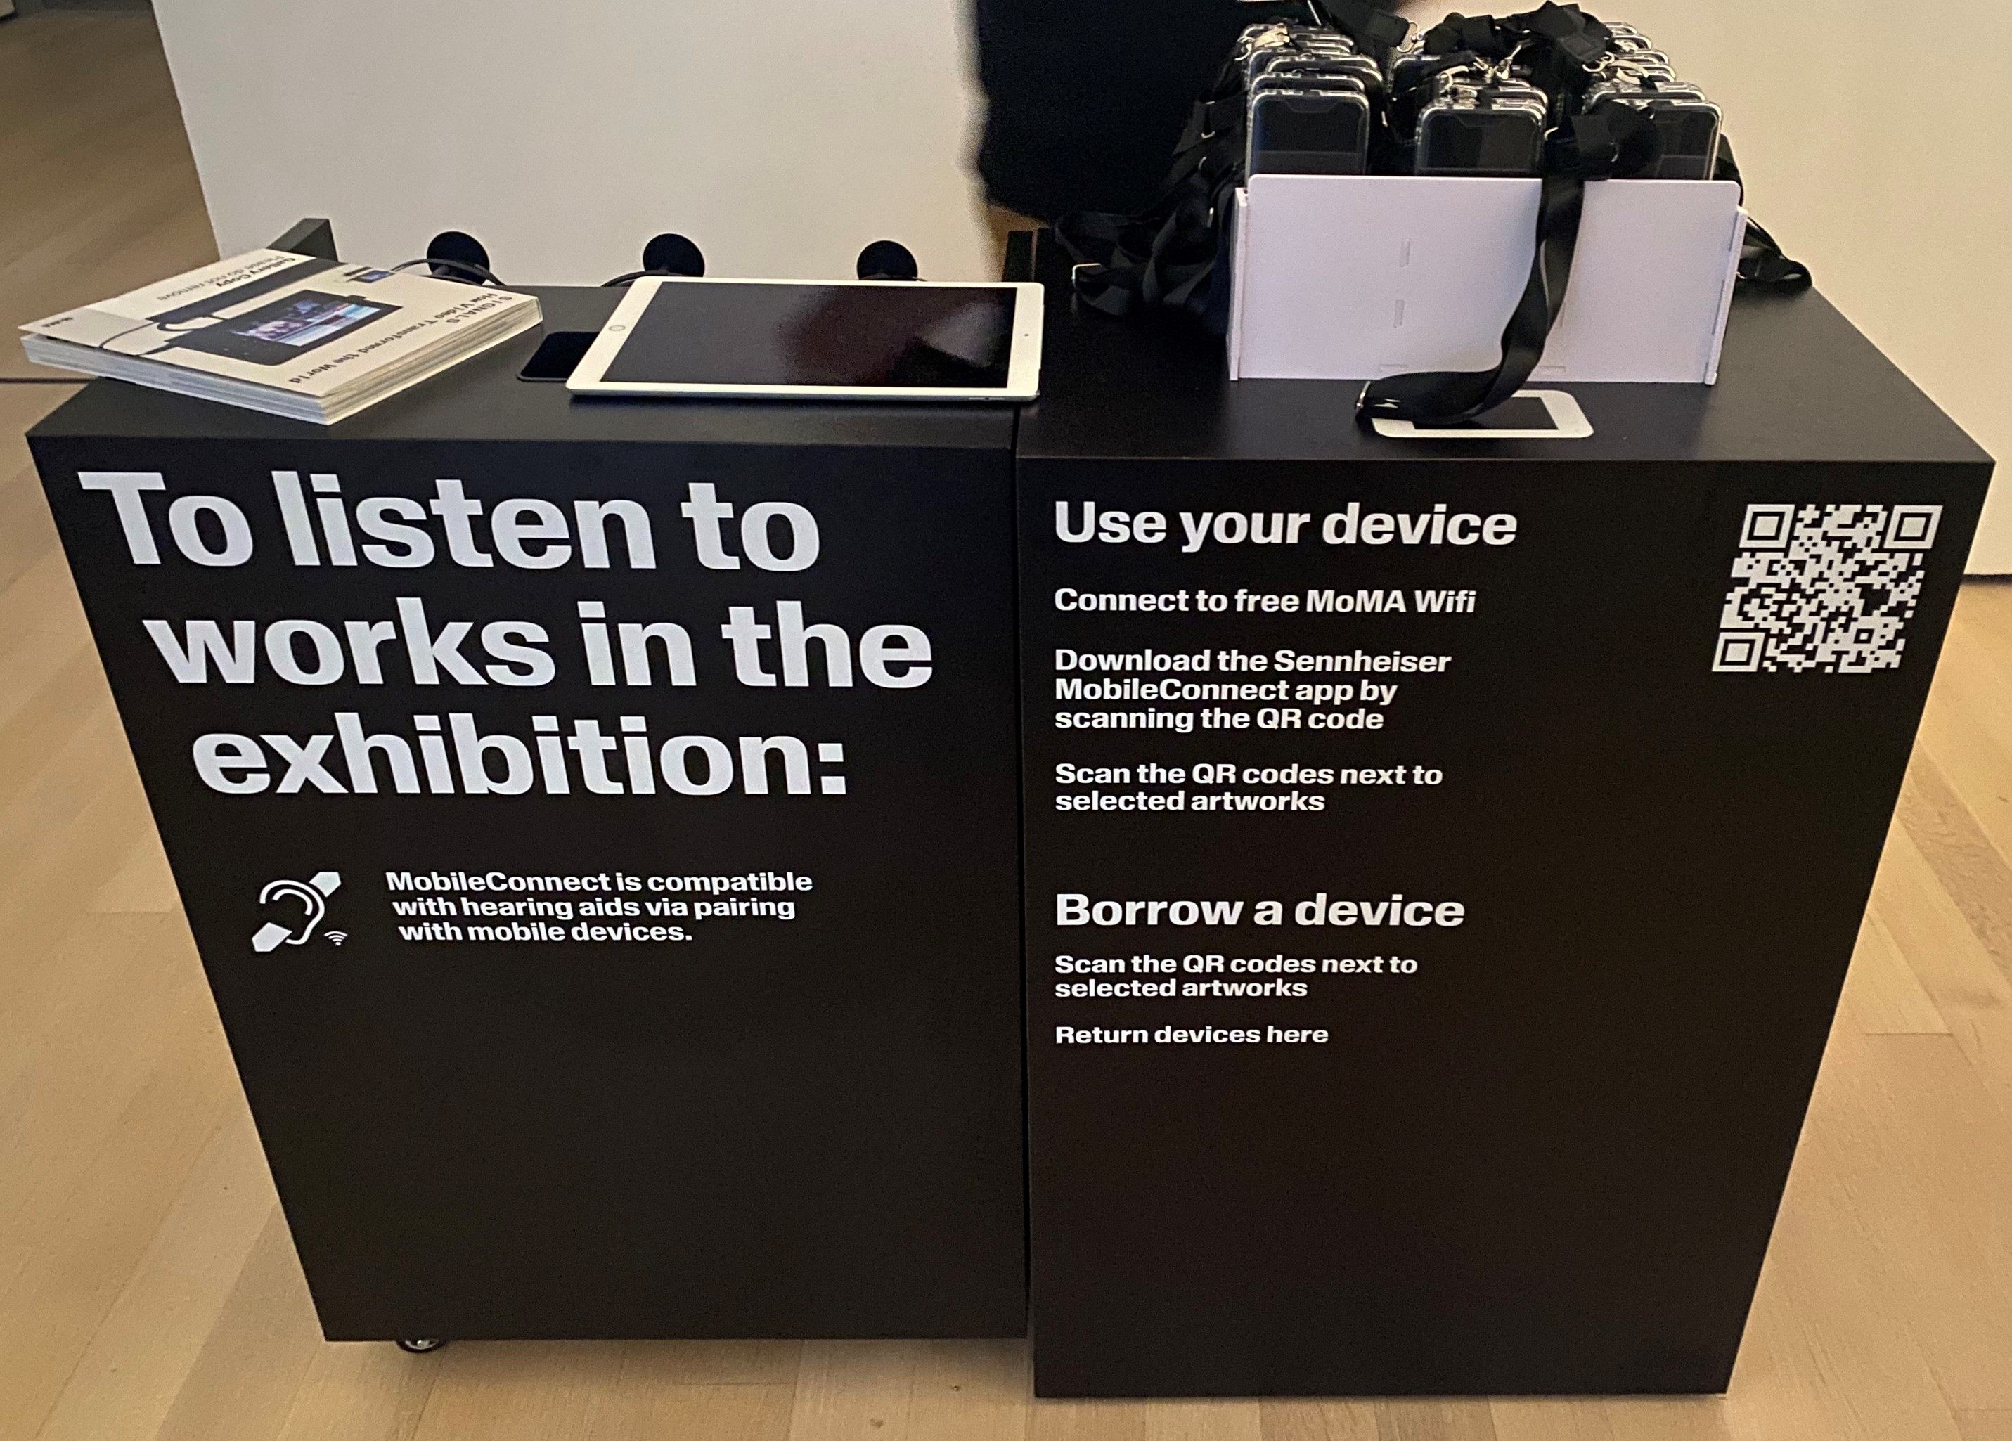

MoMA installed an additional fiber network and switches in the exhibition space to accommodate the approximately 40 MobileConnect stations. Since visitors might not have their own devices or might not understand how to download and operate the MobileConnect app, the MoMA Audio Visual Department sourced, tested, and provisioned mobile devices and headphones that would be appropriate to hand out to visitors. This included hygiene solutions for devices and headphones. MoMA’s Visitor Engagement staff were employed and trained in use of the system and how to best communicate its use to visitors.

A recent pilot at MoMA marked an unprecedented implementation of assistive listening / accessibility for audio works in a museum environment. With MobileConnect, MoMA estimates that over 95% of the art works with audio in an exhibition can be fully accessible to the hard of hearing.

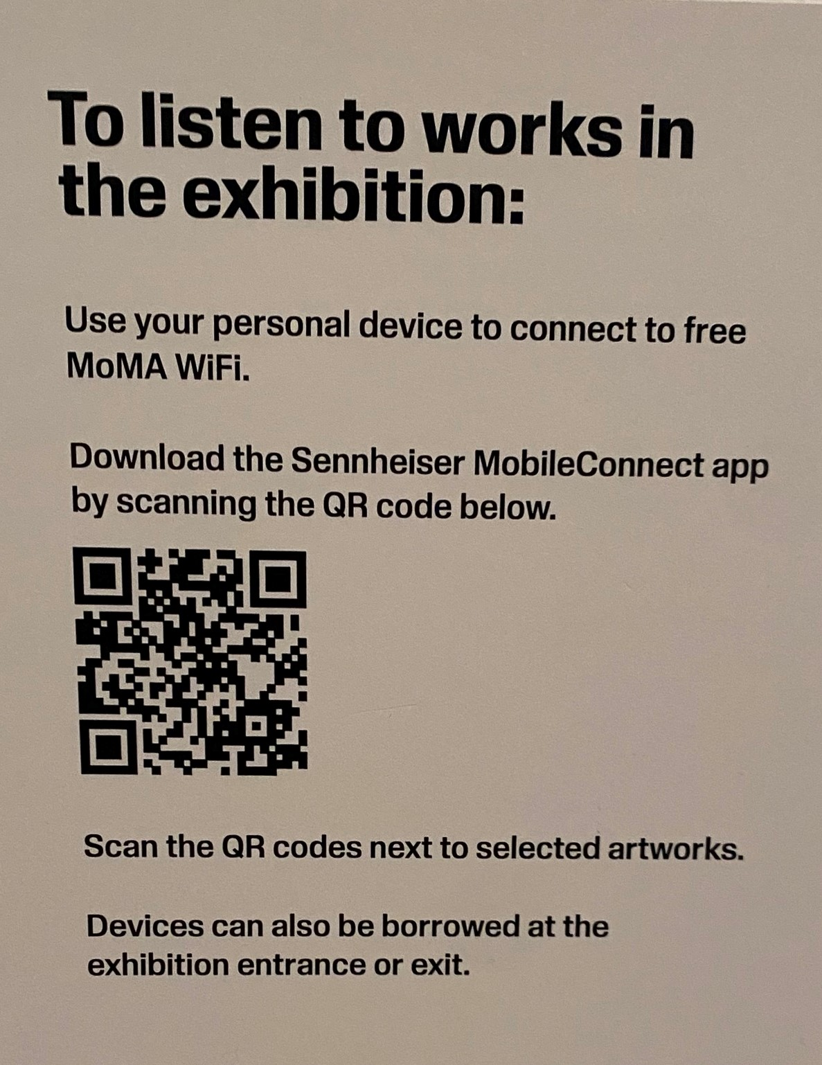

About the Sennheiser brand
We live and breathe audio. We are driven by the passion to create audio solutions that make a difference. Building the future of audio and bringing remarkable sound experiences to our customers – this is what the Sennheiser brand has represented for more than 75 years. While professional audio solutions such as microphones, meeting solutions, streaming technologies and monitoring systems are part of the business of Sennheiser electronic GmbH & Co. KG, the business with consumer devices such as headphones, soundbars and speech-enhanced hearables is operated by Sonova Holding AG under the license of Sennheiser.

www.sennheiser.com
www.sennheiser-hearing.com

Global Press Contact

Jeff Horan
+1 860-598-7539
jeffrey.horan@sennheiser.com

